Arya HajiTaheri  
Molecular Dynamics  
8/1/2017

Molecular Dynamics Assignment Report

We have executed module 2(5dfr_solv-cube_equil.pdb) assignment, for temperature 335 degrees Kelvin. The energy graph.(kJ/mole) stabilizes and reach equilibrium after ~ 85 steps.

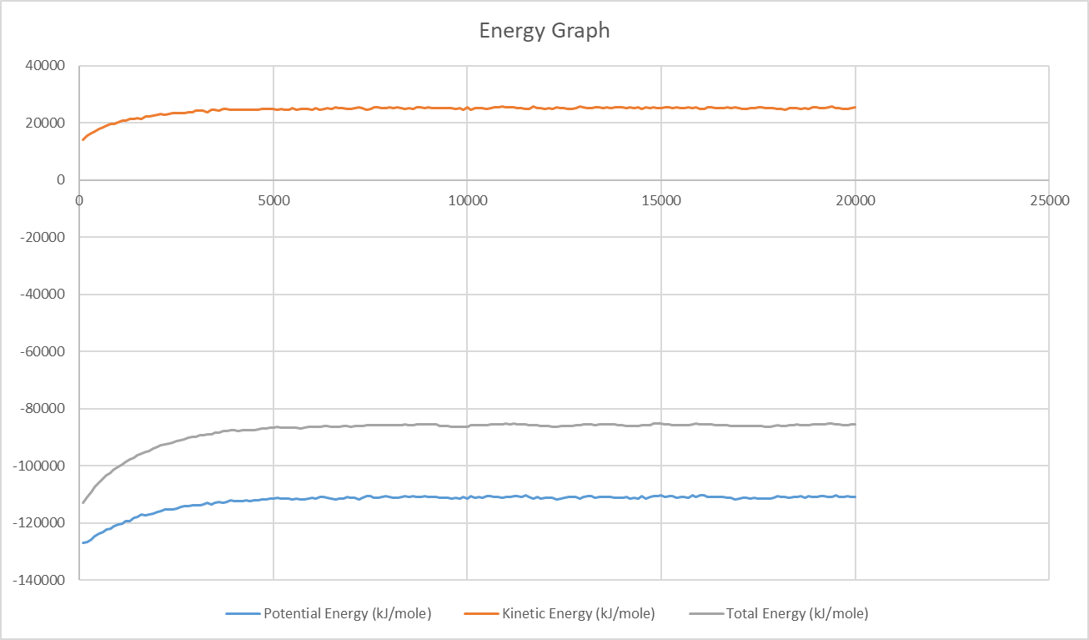

All of the data are in a separate excel file.

The average temperature is 336.0866 K which is very close to given constant 335 degrees kelvin, with a standard deviation of 2.143841.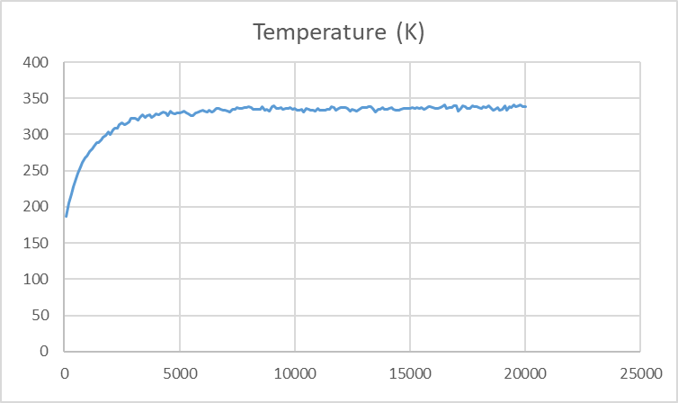

The density of the function is roughly 0.9957(g/mL).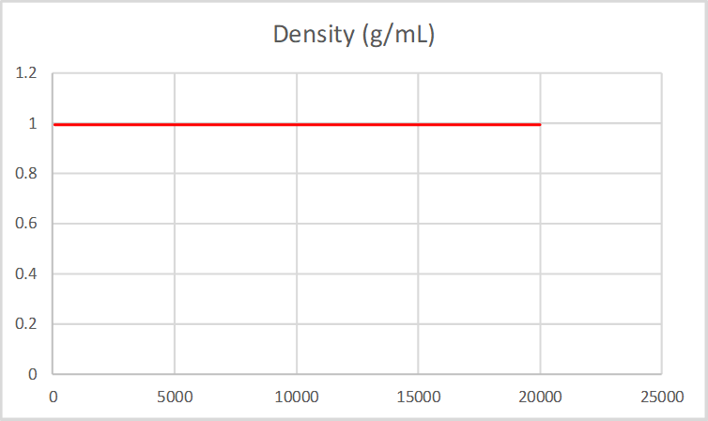

With the calculated data, and available libraries, the molecule was simulated (with additional water molecule effects):